**Global Peace in Middle East**

**Akar Gupta**

**Anurag Karmarkar**

**Introduction**

Global peacefulness has deteriorated over past few years. This is the fourth time in the last five years that the world has seen a fall in peacefulness. The average country score deteriorated by 0.34%, with 81 countries improving, and 80 recording deteriorations in peacefulness. This statistic suggests that the global peace has been on a decline in the recent past. The Global Peace Index (GPI) measures more than just the presence or absence of war. It reflects the absence of violence or the fear of violence across three areas: Militarization, Safety/Security and Ongoing Conflict. Both the Ongoing Conflict and Safety and Security domains recorded deteriorations, with only the Militarization domain recording an improvement. These aspects of global peace have sufficiently declined in the Middle East in the recent past. Our report aims to give a brief idea about this scenario in various Middle Eastern countries. All the graphs and maps are created using Tableau Software.

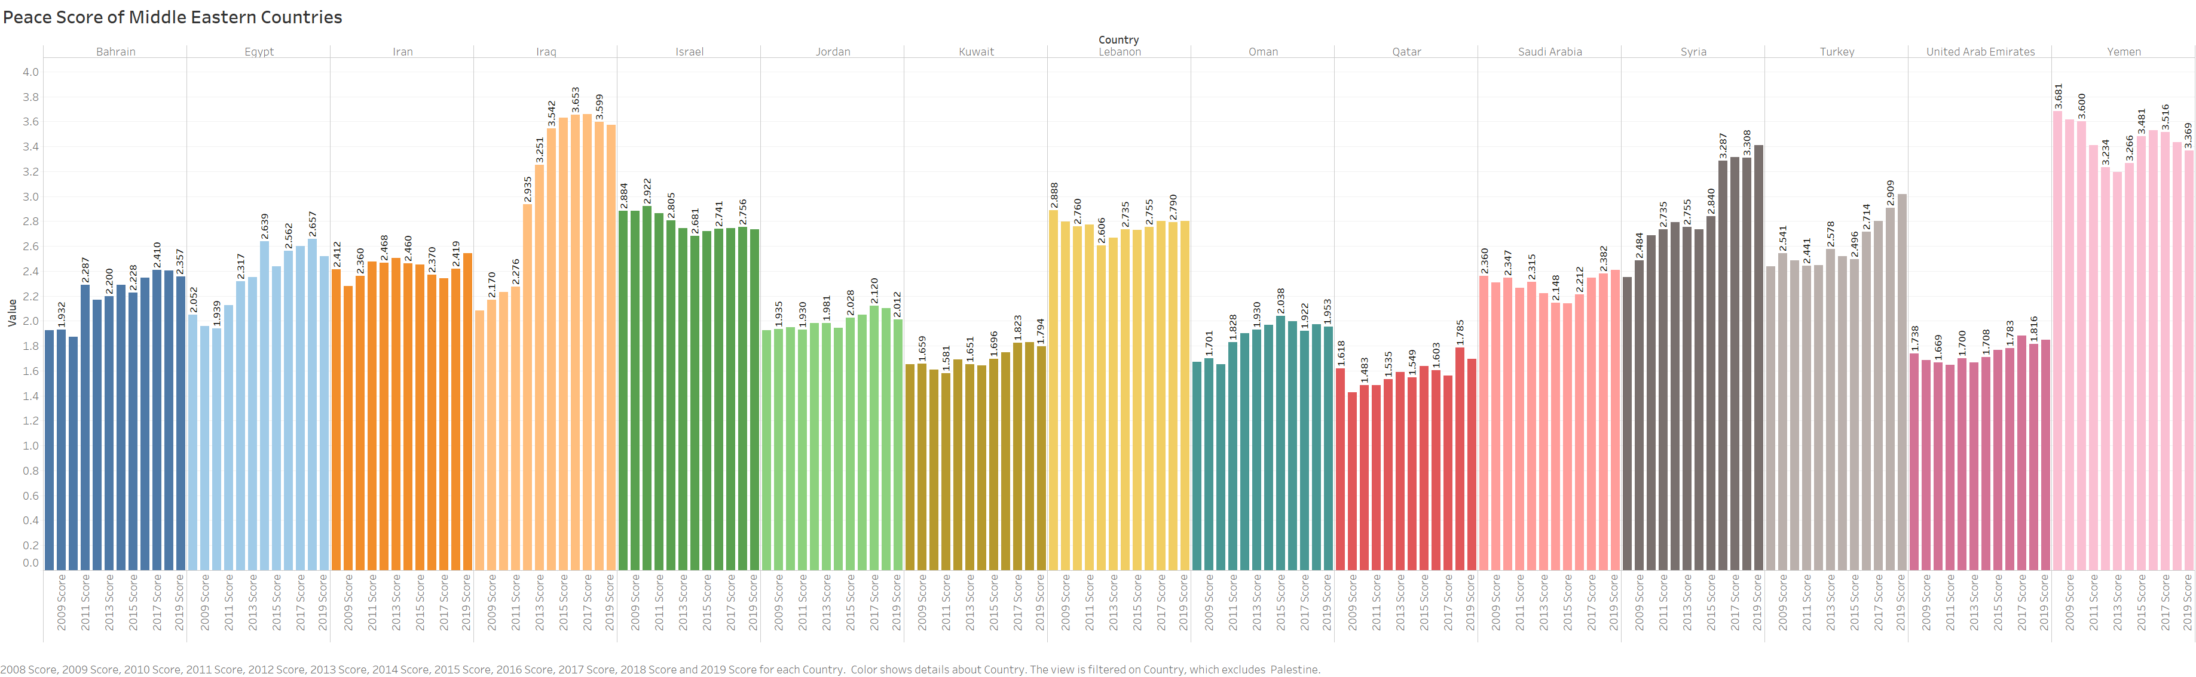

The Middle East and North Africa(MENA) remains the world’s least peaceful region, despite improvements in peacefulness for 11 countries on the 2020 GPI. While both the Militarisation and Ongoing Conflict domains improved on average, there was a deterioration on the Safety and Security domain, owing to increases in the likelihood of violent demonstrations, and a rise in political instability. Five of the ten least peaceful countries in the world are located in the MENA

region, with only Qatar, Kuwait, and the United Arab Emirates being ranked in the top 50 most peaceful countries.

**Terrorist Attacks and Urban Disorders:**

**No of Terrorist Attacks:**

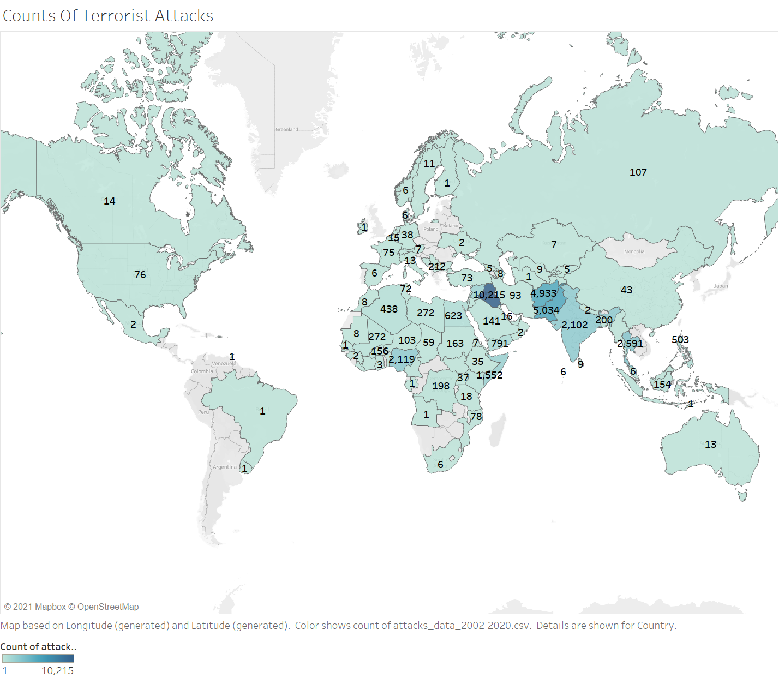

This map shows the number of terror attacks in the world between 2002 to 2012. It can be observed that the highest number of terror attacks have occurred in the Middle East. The Middle East and North Africa region has the least number of peaceful countries. Iraq is the country which has the greatest number of attacks; the number being around 10,000. Iraq has seen the highest number of conflicts in the past decade. It can be noted that apart from the middle east, around 10,000 terror attacks were reported in Afghanistan and Pakistan in last two decades. It indicates that these countries should also be considered while looking for a solution to this problem.

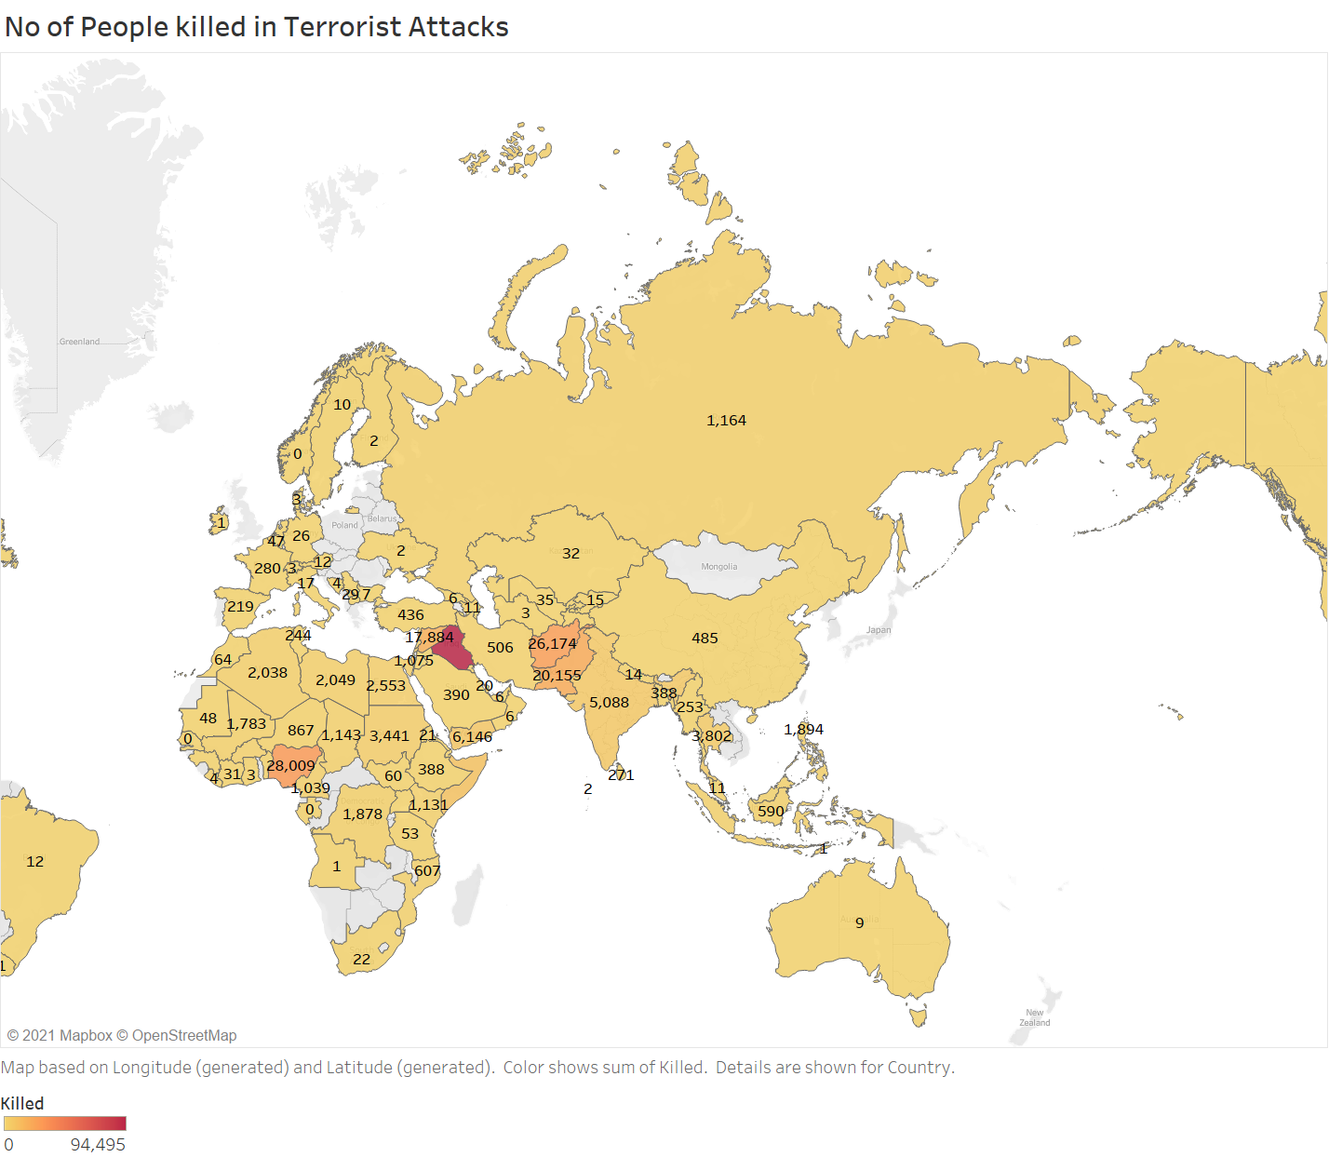

This map shows the number of people killed during the terror conflicts. We can see that the highest number of people killed is around 94,000. This is a huge amount of people to die in terrorist attacks. The country that follows this number is Nigeria with a death toll of 28,000 people. Afghanistan and Pakistan have a count of around 26,000 and 20,000 respectively. Syria follows these figures with a death toll of almost 18,000 people. We can see that the death toll of Iraq is almost the same a s that of the other four countries combined. This map makes it clear that the scenario in Iraq is very grim.

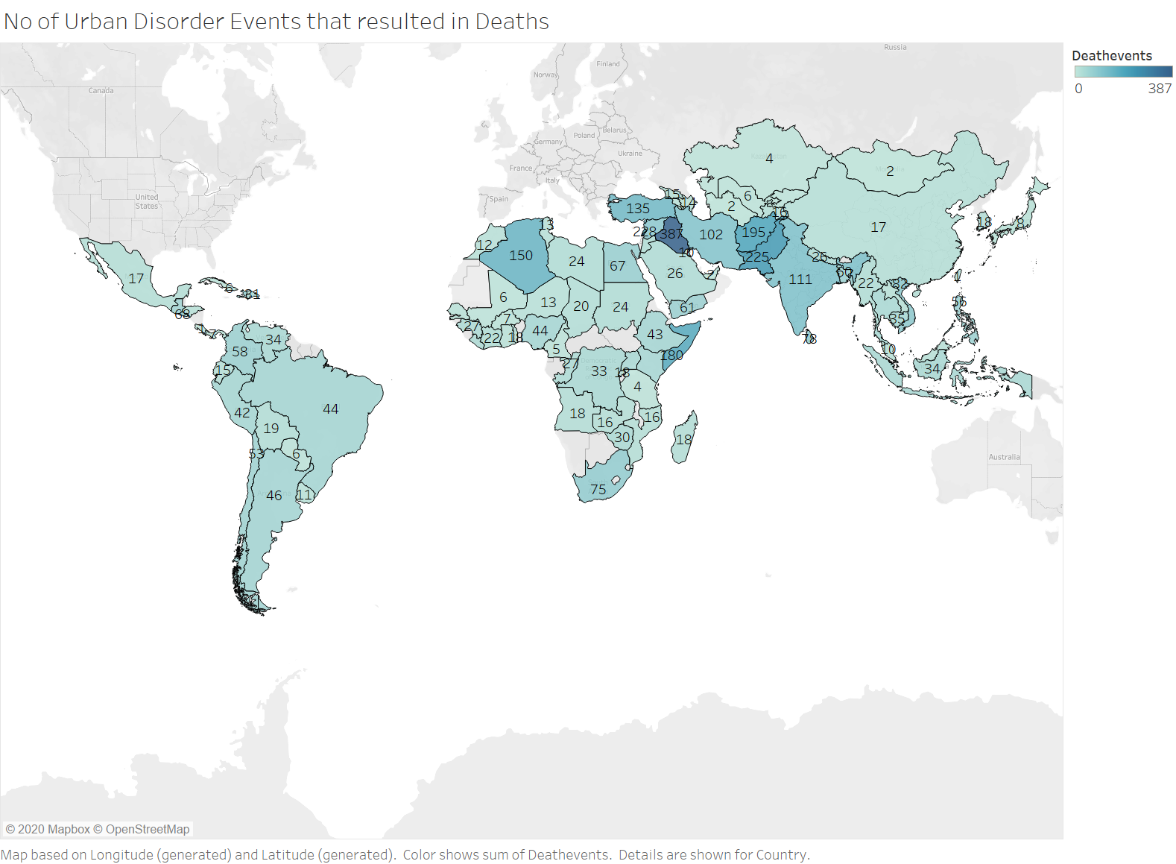

Social disorder refers to the events which cause an unrest in society like strikes demonstrations, rioting, assassinations and coups. A total of 9018 events have been reported throughout the world in past 3 decades which have caused a social unrest. If we look at the middle eastern region, we can see that the maximum number of such attacks have taken place in Iraq (387) then comes Syria with 228 attacks if we focus on the MENA region, we can see the belt of dark blue color. Even Pakistan and Afghanistan have faced such issues a lot in past decades with 225 and 195 events respectively.

**Refugee Migration Trends:**

The following map shows the amount of migration taken place in the last two decades. The map gives information about the number of migrated from the given country to the rest of the world. People have migrated to many of the developed countries is search of better livelihood.. Most of the migration has taken place from Middle east to central and eastern European countries. Migration has also taken place in large numbers to Australia and the United States of America.

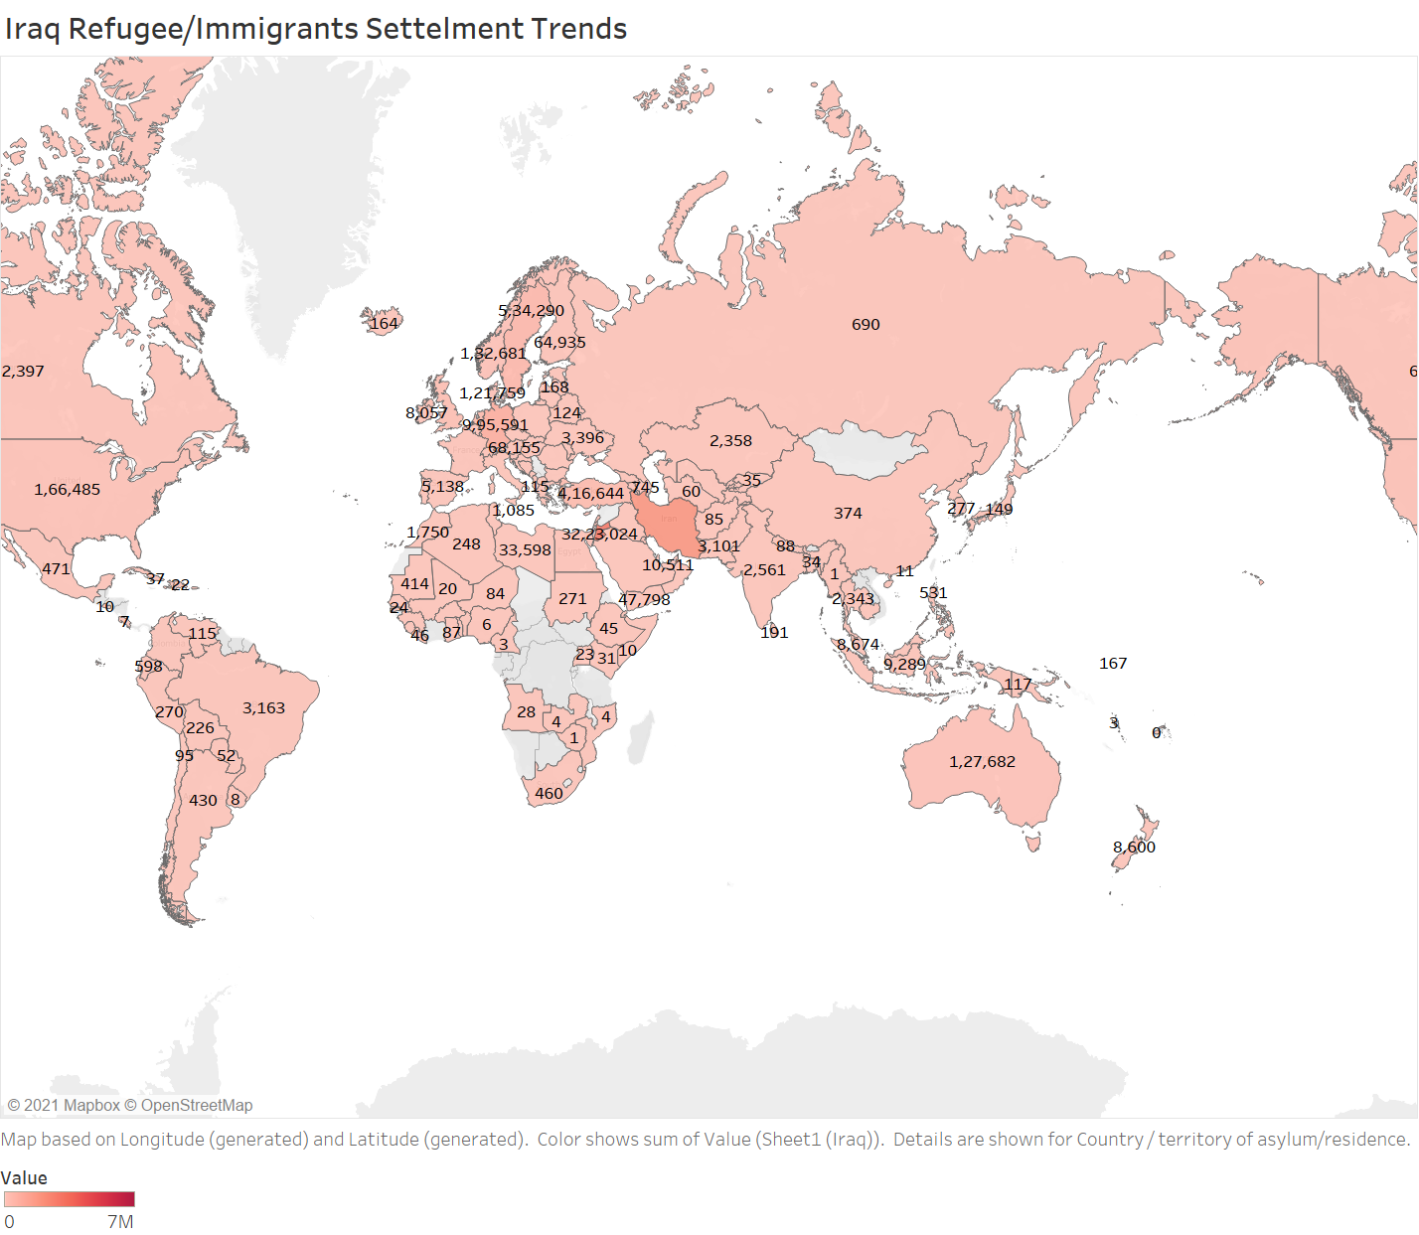

It is evident from the previous maps that the quality of life in Iraq is not very good due to the constant unrest and war. Highest migration has taken place in Jordan (3,223,024), Iran (2,088,783) and Germany (995,591). Most of the migration has taken place from Iraq to the neighboring countries. Some amount of migration has also taken place in Germany and other European countries.

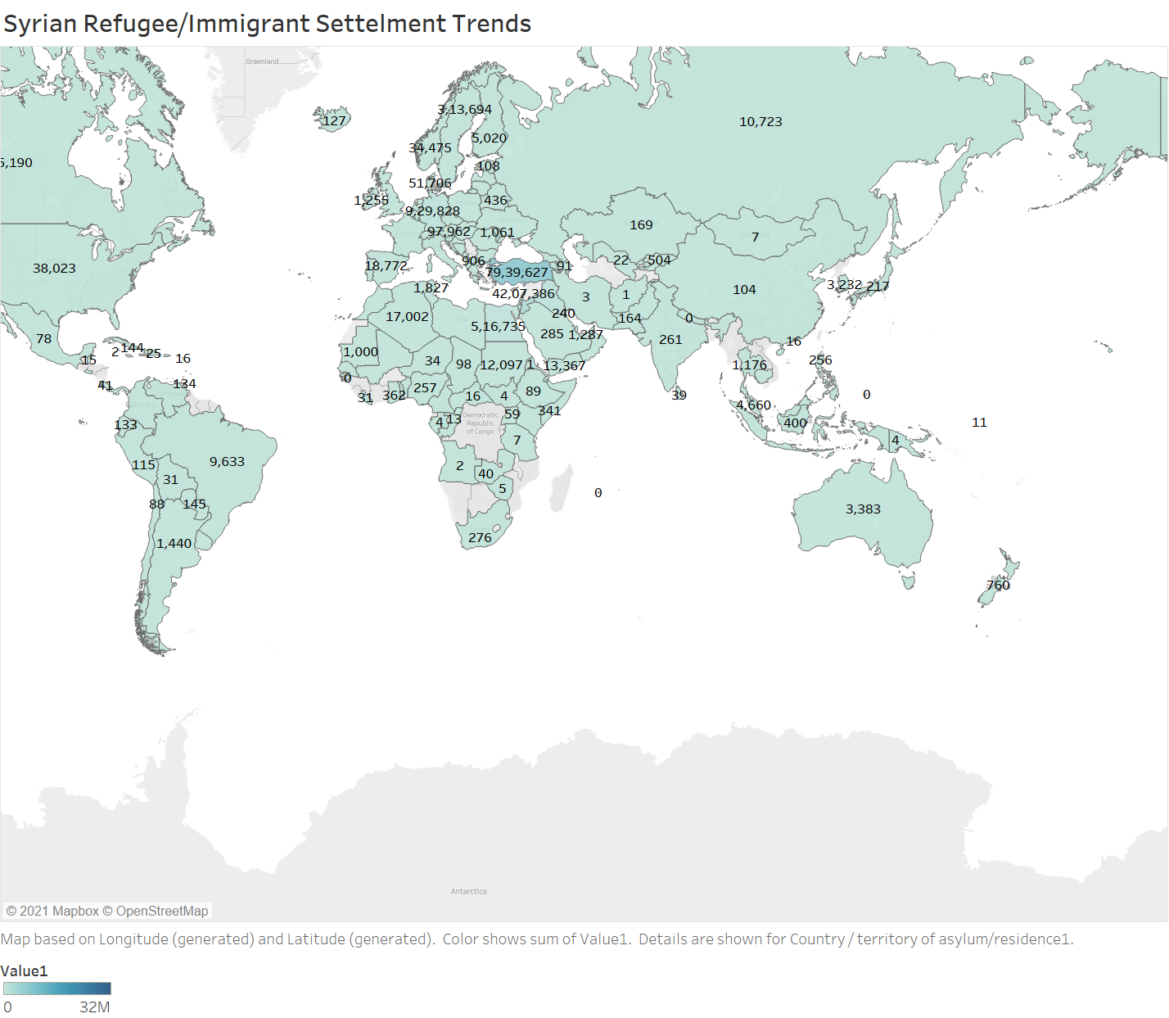

It can be seen from the previous maps that the quality of life in Syria is not very good due to the constant unrest and war. Highest migration has taken place in Turkey (7,939,627), Lebanon (4,207,386) and Germany (929,828). Most of the migration has taken place from Syria to the neighboring countries. Some amount of migration has also taken place in Germany and other European countries.

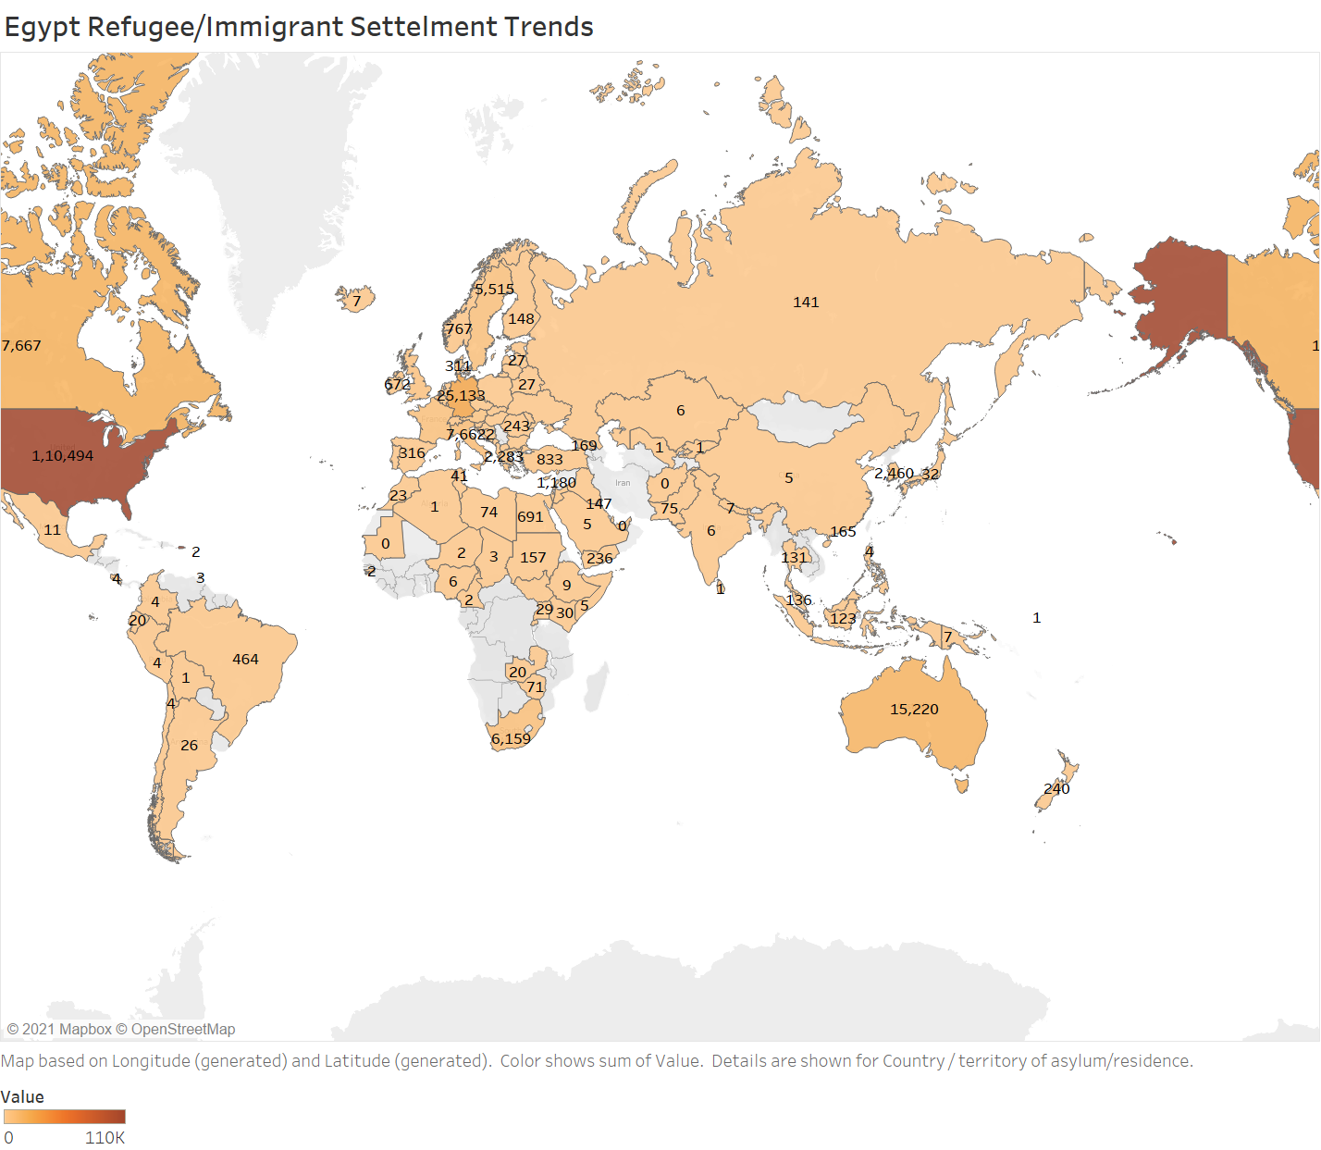

We know that recently Egypt has seen citizen protests against the government and the violence in the Arab Spring protests have made people to move out of country. Majorly people from Egypt moved to United States(110,494), Germany (25,133)Canada(17,667) and Australia(15,220).

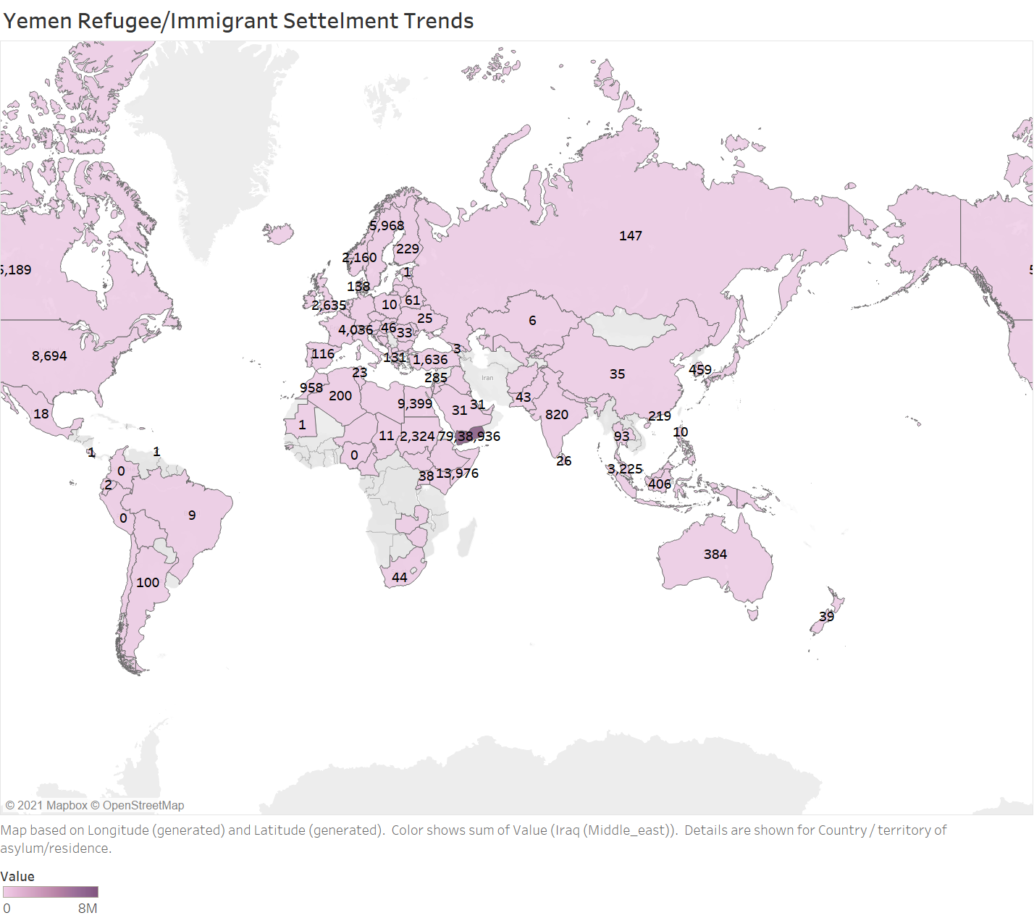

People in Yemen have seen a lot of civil wars and uprisings in past few decades. Recently Yemen saw its 7th Sahad war because of all this there is an unrest in area. The migration pattern in Yemen is bit different because of this. Around 8 million people had to migrate from one part of country to other. Other than this mostly people migrated to northern Africa, USA and Canada.

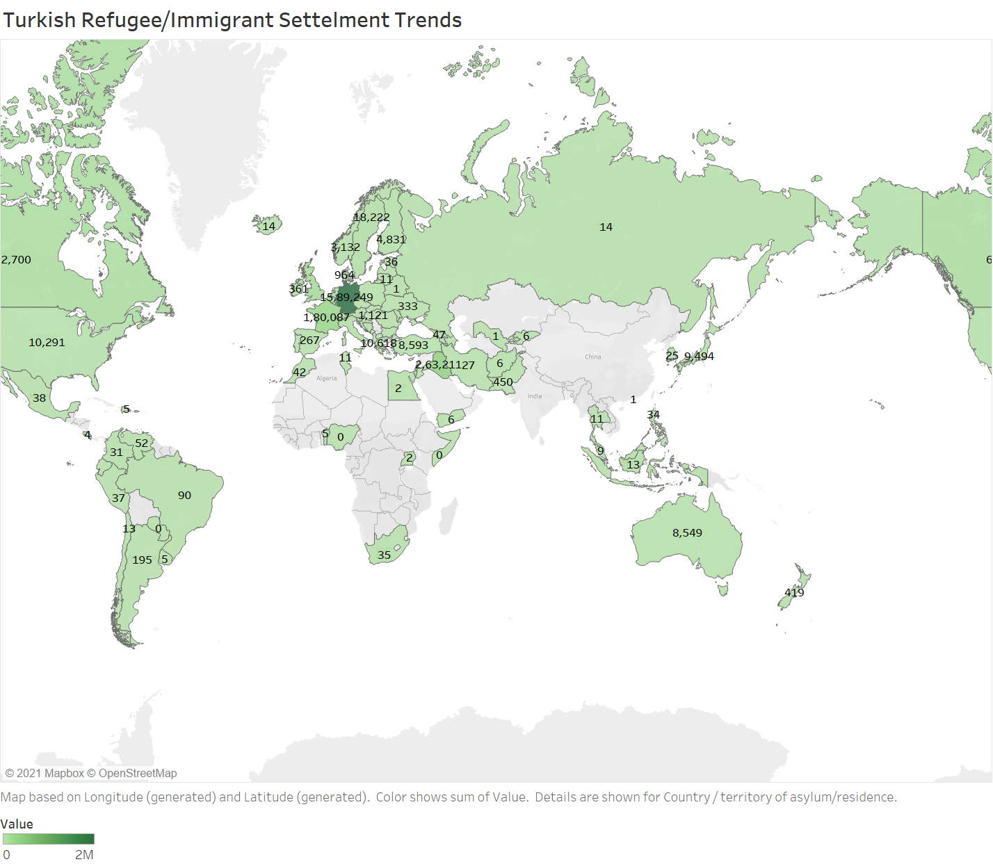

It can be seen from the previous maps that the quality of life in Turkey is not very good due to the constant unrest and war. Highest migration has taken place in Germany (1,589,249), France (180,087) and Iraq (263,211). Most of the migration has taken place from Turkey to the Germany and other European countries.

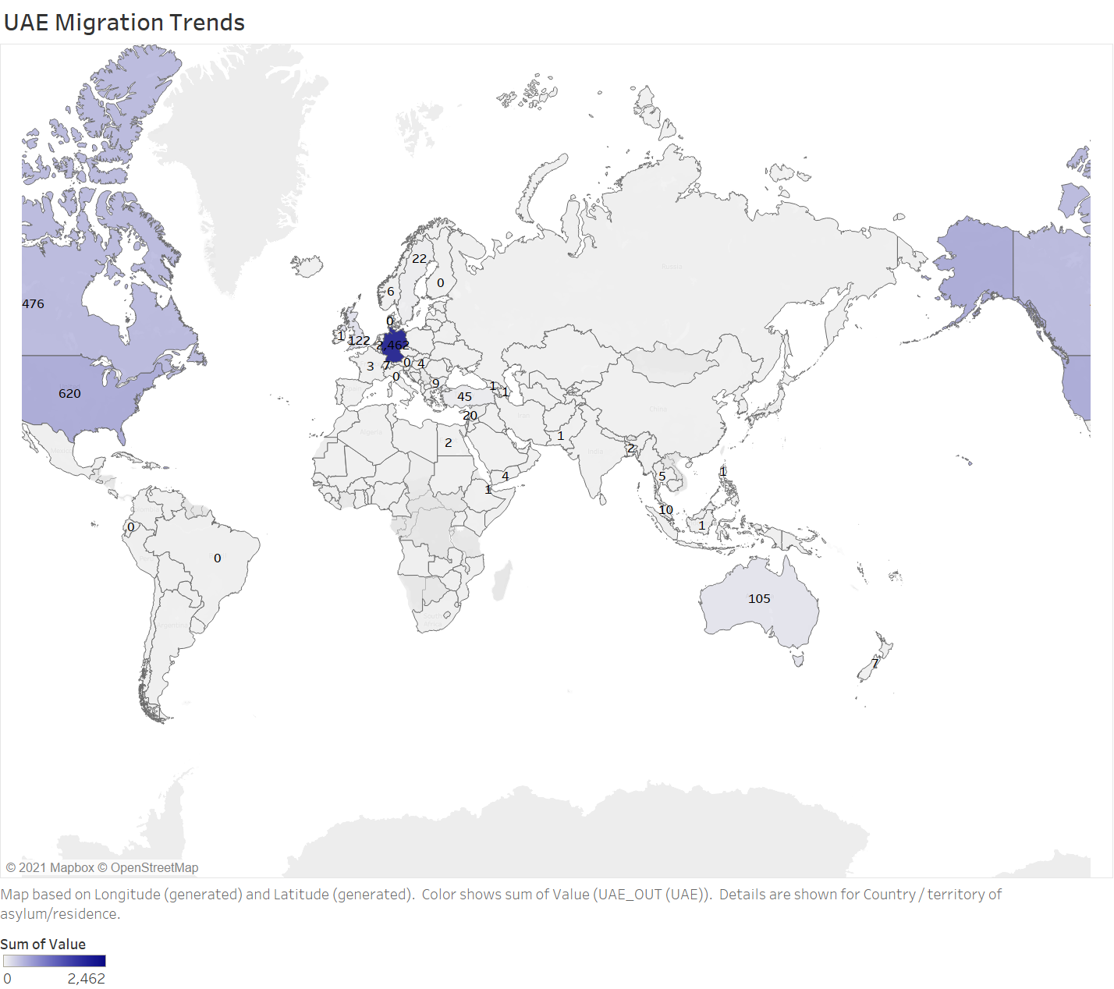

For our analysis we have taken UAE as our baseline country. Being in the volatile region of middle east it has a very low peace score and the way they have promoted their tourism we have seen Dubai as one of the most visited location in world. This map of migration from UAE shows that the amount of people migrated are very less. And these people can we just moved to a different country due to work or business perspectives.

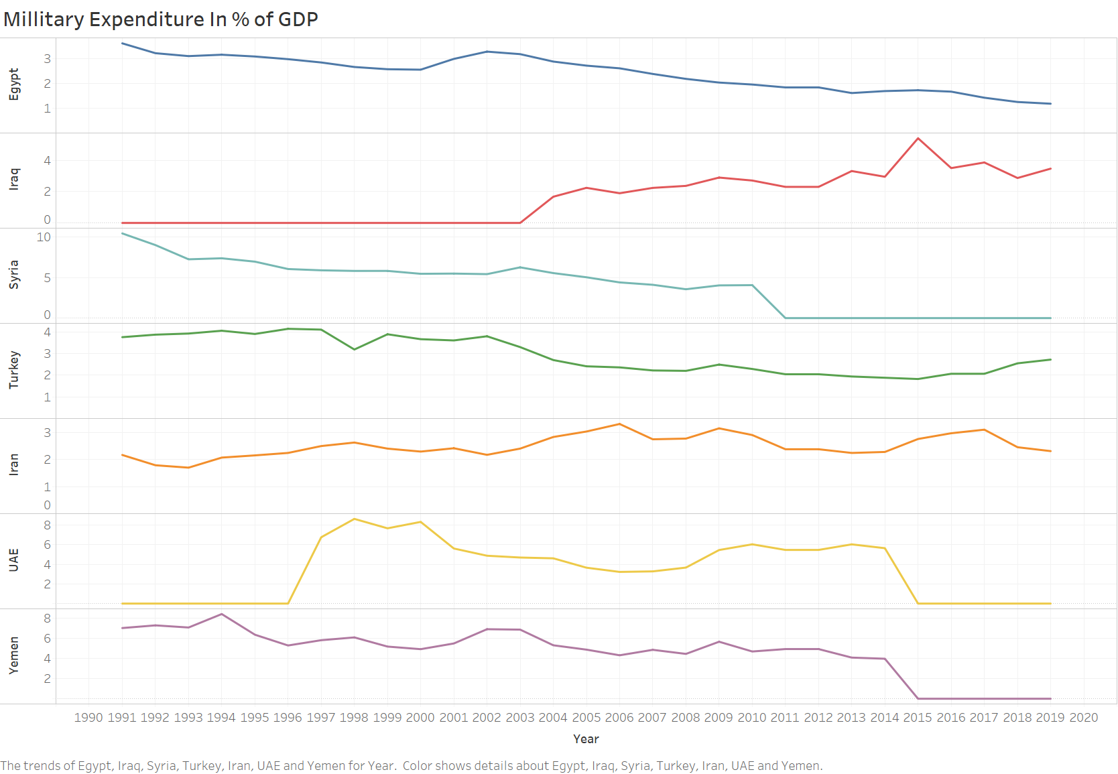

The preceding graph shows the trends in military expenditure of some middle eastern countries to the percentage of their GDP. The percentage GDP is being considered to normalize the data. This provides an ease when the data of different countries is to be compared. The idea of making this graph was to establish a relation between the military spending of the country and the peace score of the country. The military spending of Iraq rises from a small 1% in 2004 to around 6% in year 2015. In a decade Iraq had to put more money from its income to maintain peace. Iran has followed a similar trend as its military spending has also increased. However, it has stayed between 2 - 3% of the country’s GDP. The military spending of countries such as Syria, Yemen and Egypt have also seen a declining trend. However, the peace score of these countries is quite high. UAE has a trend of changing the amount of the GDP spent on the military based on its internal political and socio-economic conditions. Other than Iraq we cannot establish a direct relationship between countries peace score and their military expenditure. However, we can say its surely one of the important factors. Other than Iraq, a relation cannot be directly established between countries’ peace score and their military expenditure. However, it can surely be said that military spending is one of the important factors in determining global peace, but it is seldom directly related.

**Conclusion**

Looking at all the above analysis we can say that it is very important for a country to maintain peace. If there is prolonged war and conflict in a country, then it loses its human resources. As standard of living deteriorates, the country is pushed into something called ‘Conflict Trap’. As many people migrate from there in search of better living conditions, it leads to a forced brain drain. With countries increased % use of GDP in defense and military expenditure to control agitation and violence the less resources are left for them to spend on things which can be used for benefit of its citizens or at improving their living standards.

In this analysis we looked at UAE as our baseline country. It is in the volatile region of Middle East but the way it has maintained its peace score and rank is commendable. It can be treated as a model country as in recent decades they have built their capital as one of the most desirable cities to live in. Their policies with its neighbors and their investment on its residents is one of the biggest reasons for the country’s success and other leaders should learn from their efforts.

**References:**

* En.wikipedia.org. 2021. *Global Peace Index*. [online] Available at: <https://en.wikipedia.org/wiki/Global_Peace_Index#:~:text=Global%20Peace%20Index%20(%20GPI)%20is%20a%20report,world's%20population)%20according%20to%20their%20levels%20of%20peacefulness.> [Accessed 15 January 2021].
* Kaggle.com. 2021. *Urban Social Disorder*. [online] Available at: <https://www.kaggle.com/waltervanhuissteden/urban-social-disorder?select=cities.csv> [Accessed 31 January 2021].
* Sipri.org. 2021. *SIPRI Military Expenditure Database | SIPRI*. [online] Available at: <https://www.sipri.org/databases/milex> [Accessed 15 December 2020].
* Refugees, U., 2021. *UNHCR - Refugee Statistics*. [online] UNHCR. Available at: <https://www.unhcr.org/refugee-statistics/> [Accessed 10 December 2020].
* Visionofhumanity.org. 2021. [online] Available at: <https://www.visionofhumanity.org/wp-content/uploads/2020/10/GPI_2020_web.pdf> [Accessed 25 January 2021].
* Kaggle.com. 2021. *Religious Terrorist Attacks*. [online] Available at: <https://www.kaggle.com/argolof/predicting-terrorism> [Accessed 4 December 2020].
* En.wikipedia.org. 2021. *Conflict trap*. [online] Available at: <https://en.wikipedia.org/wiki/Conflict_trap#:~:text=Conflict%20trap%20is%20a%20term%20to%20describe%20the,this%20pattern%20and%20coined%20the%20term%20%E2%80%98conflict%20trap%E2%80%99.> [Accessed 2 February 2021].